G999999
G9999999 (Don’t change this number)
Advices on the preparation for submission to KSCM
Gil-Dong Hong* and Gil Dong Kim
Department of Mechanical Engineering
Hankook University, Seoul, South Korea
*E-mail: abc@hankook.ac.kr (presenter’s email)

Extended Abstract
This template can be used to prepare manuscripts for KSCM. For the preparation of a new manuscript, using A4-sized papers is highly recommended. The paper title with Times New Roman should be centered and bold faced in 12-point font. For the main text, please use 11-point Times New Roman. First-order headings (sections) should be 12-point capital Times New Roman, centered, and enumerated using Arabic numbers. Second-order headings (subsections) should be 11-point Times New Roman, left aligned, and enumerated. All paragraphs are indented. For this LaTeX template, whenever you insert a blank line, your new paragraph is automatically indented.

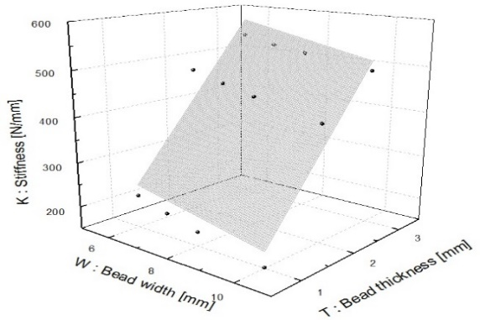
Fig. 1. A sample of figure caption

Acknowledgement
This work was supported by Basic Science Research Program through the National Research Foundation of Korea (NRF) funded by the Ministry of Education, Science and Technology (Grant no. 2011-001111).

Reference
1. X. Xie and M. Mirmehdi, RAGS: Region-Aided Geometric Snake, IEEE Transactions on Image Processing, 13 (2004), 640-652. (Reference format for journal papers)
2. D. Gil and P. Radeva, Curvature vector flow to assure convergent deformable models for shape modeling, Lecture Notes in Computer Science, Springer Verlag, Proceedings of EMMCVPR, Lisbon, Portugal 2003. (Reference format for conference proceeding papers)
3. G. Aubert and P. Kornprobst, Mathematical problems in image processing, Applied Mathematical Sciences 147, Springer Verlag, New York, 2002. (Reference format for books)

